Chapter 8, Solution 38.

Refer to the circuit in Fig. 8.86. Calculate i(t) for t > 0.
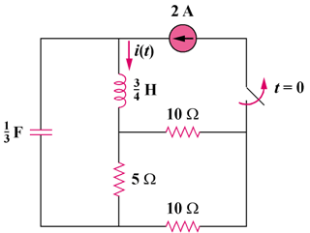

2[1 – u(t)] A


Figure 8.86
For Prob. 8.38.

Solution
At t = 0—, the equivalent circuit is as shown.

10 Ω

+

v

−

5 Ω

i₁

i

2 A

10 Ω

i(0) = 2A, i₁(0) = 10(2)/(10 + 15) = 0.8 A

v(0) = 5i₁(0) = 4V

For t > 0, we have a source-free series RLC circuit.

R = 5||(10 + 10) = 4 ohms

ω_{o} = 1/ = 1/ = 2

- = R/(2L) = (4)/(2x(3/4)) = 8/3

s_{1,2} = -4.431, -0.903

i(t) = [Ae^{-4.431t} + Be^{-0.903t}]

i(0) = A + B = 2 (1)

di(0)/dt = (1/L)[-Ri(0) + v(0)] = (4/3)(-4x2 + 4) = -16/3 = -5.333
Hence, -5.333 = -4.431A – 0.903B (2)

From (1) and (2), A = 1 and B = 1.

i(t) = [e^{-4.431t} + e^{-0.903t}] A

